###### *CSE 473 – Introduction to Computer Networks*

Lab 2 Report – 85 Points

##### *Gilad Gabriel Tsehori, Gai Ashkenazy*

***Part A (20 points).*** Place a copy of your source code for *TcpMapServer* here.

import java.io.*;

import java.net.*;

import java.util.HashMap;

import java.util.Map;

public class TcpMapServer {

public static void main(String args[]) throws Exception {

// process arguments

int port = 30123;

if (args.length > 1) port = Integer.parseInt(args[1]);

InetAddress bindAdr = null;

if (args.length > 0) bindAdr = InetAddress.getByName(args[0]);

// create and bind listening socket

ServerSocket listenSock = new ServerSocket(port, 0, bindAdr);

HashMap <String, String> storage = new HashMap<>();

while (true) {

// wait for incoming connection request and create new socket to

handle it

Socket connSock = listenSock.accept();

// create buffered versions of socket's in/out streams

BufferedInputStream in = new BufferedInputStream(

connSock.getInputStream());

BufferedOutputStream out = new BufferedOutputStream(

connSock.getOutputStream());

while (true) {

// Receiving a new packet (request) from client

byte[] buf = new byte[1024];

// init buf array to get the command from client

int nbytes = in.read(buf, 0, buf.length);

if (nbytes < 0) break;

// Processing the client's request, and constructing an answer

String clientRequest = new String(buf, 0, buf.length, "US-

ASCII");

String[] processedRequest = clientRequest.split(":");

String answerToClient = "";

if (!checkInput(processedRequest)) {

answerToClient = "Error:unrecognizable input:" +

clientRequest;

} else {

// The input is valid, constructing an answer which

// corresponds to the defined specifications

String res;

String clientKey = "";

if (processedRequest.length > 1) {

clientKey = processedRequest[1].trim();

}

String commandTrimed = processedRequest[0].trim();

switch (commandTrimed) {

case "get":

answerToClient =

(storage.containsKey(clientKey)) ?

"ok:" + storage.get(clientKey) :

"no match";

break;

case "remove":

answerToClient =

(storage.containsKey(clientKey))?

"Ok" : "no match";

storage.remove(clientKey);

break;

case "put":

String clientValue = processedRequest[2].trim();

res = storage.put(clientKey, clientValue);

answerToClient = (res == null) ? "Ok" :

"updated:" + clientKey;

break;

case "get all":

for (Map.Entry<String, String> entry :

storage.entrySet()){

answerToClient += entry.getKey() + ":" +

entry.getValue() + "::";

}

answerToClient = answerToClient.substring(0,

answerToClient.length() - 2);

break;

}

answerToClient = answerToClient.trim();

answerToClient += "\n";

}

buf = answerToClient.getBytes("US-ASCII");

out.write(buf, 0, buf.length);

out.flush();

}

// close connections and readers

connSock.close();

in.close();

out.close();

}

}

/**

* Checks if the client's request complies with the specifications

* @param command The different parts of the requested query

* @return Whether the request should be processed or not

*/

private static boolean checkInput(String[] command) {

String temp = command[0].trim();

if (temp.equals("get all") && command.length == 1) {

return true;

} else if ((!command[0].equals("get") && !command[0].equals("put")

&& !command[0].equals("remove")) || command.length > 3)

return false;

else if (command[0].equals("get") || command[0].equals("remove"))

return command.length <= 2;

return command.length == 3;

}

}

***Part B (10 points).***Place a copy of your source code for *TcpMapClient* here.

import java.io.*;

import java.net.*;

public class TcpMapClient {

public static void main(String args[]) throws Exception {

// connect to remote server default port is 30123

int port = 30123;

if (args.length > 1) port = Integer.parseInt(args[1]);

Socket sock = new Socket(args[0], port);

// create buffered reader & writer for socket's in/out streams

BufferedReader in = new BufferedReader(new InputStreamReader(

sock.getInputStream(),"US-ASCII"));

BufferedWriter out = new BufferedWriter(new OutputStreamWriter(

sock.getOutputStream(),"US-ASCII"));

// create buffered reader for System.in

BufferedReader sysin = new BufferedReader(new InputStreamReader(

System.in));

String line;

while (true) {

line = sysin.readLine();

if (line == null || line.length() == 0) break;

// write line on socket and print reply to System.out

out.write(line); out.newLine(); out.flush();

String serverAnswer = in.readLine();

System.out.println(serverAnswer);

}

//close all Readers and sockets

sock.close();

in.close();

out.close();

sysin.close();

}

}

***Part C (10 points).***Use the provided *localScript* to test your client and server. You may do this testing on any Unix (including MacOS) or Linux computer (shell.cec.wustl.edu or onl.wustl.edu). Paste a copy of the output below.

Ok

Ok

Ok

ok:slim jim

ok:ho ho

ok:world

goodbye:world::foo bar:slim jim::hah:ho ho

Error:unrecognizable input:get

Error:unrecognizable input:foo:who

no match

Ok

ok:toast is tasty

updated:hah

goodbye:world::foo:toast is tasty::foo bar:slim jim::hah:yolo

goodbye:world::foo:toast is tasty::foo bar:slim jim::hah:yolo

no match

goodbye:world::foo:toast is tasty::foo bar:slim jim::hah:yolo

Ok

goodbye:world::foo:toast is tasty::hah:yolo

***Part D (15 points).*** In the remaining parts of the lab, you will be testing your application in ONL. Begin by logging on to a Linux desktop (see Using a Remote Linux Desktop). Use the RLI to reserve an experimental network using the provided configuration file, *cse473-lab2.onl* (remember to first open an *ssh* connection to ONL with the tunnel required by the RLI), and commit your network. Open two separate *ssh* windows, one connecting to the host *h4x2* and the other to the host *h7x1* (remember to load the topology file first). First, start the server using the window for host *h7x1.* When starting the server, you should specify the host name (*h7x1*) or IP address (192.168.7.1) for the host in the experimental network. Use the default port number. Run the command in the “background” by putting an ampersand (&) at the end of the line. This will allow you to use the window for command input, even while the server is running (read the job control section of the *bash* manual to learn more about running jobs in the foreground and background). Note that once you start the server, it will “run forever” until you stop it. One simple way to do this is to type kill %1. Note that if you have multiple jobs running in the background, you will need to substitute the appropriate job number for %1. See the bash manual for details.

Now that your server is running in the background, type the following command in the window for *h7x1*.

netstat -an | grep 30123

and paste a copy of the output below.

tcp6 0 0 192.168.7.1:30123 :::* LISTEN

Now, start the client on *h4x2* (supplying the appropriate arguments) and then re-run *netstat* on *h7x1* and paste the output below.

tcp6 0 0 192.168.7.1:30123 :::* LISTEN

tcp6 0 0 192.168.7.1:30123 192.168.4.2:59166 ESTABLISHED

Explain the *netstat* output in the two cases. You should read the man page on *netstat* before answering this part (type “man netstat” to get the man page).

*Utilizing the -a and -n flags of netstat, we are able to see all the connections available to the host at the time the command was executed.*

*In our case, before the client program was executed, the server was listening on the specified IP address and port (set by the server program). We can see it thanks to the -a flag, and make sure that this is our server with the -n flag.*

*After executing the client command and re-running the netstat command, we can now able see that a connection was established, and also analyze which IP address the client is running on and the port on the client’s machine that is attached to the socket communicating with the server.*

Now, run the provided *remoteScript* on *h4x2*. Paste the output from your run below.

Ok

Ok

Ok

ok:slim jim

ok:ho ho

ok:world

goodbye:world::foo bar:slim jim::hah:ho ho

Error:unrecognizable input:get

Error:unrecognizable input:foo:who

no match

Ok

ok:toast is tasty

updated:hah

goodbye:world::foo:toast is tasty::foo bar:slim jim::hah:yolo

goodbye:world::foo:toast is tasty::foo bar:slim jim::hah:yolo

no match

goodbye:world::foo:toast is tasty::foo bar:slim jim::hah:yolo

Ok

goodbye:world::foo:toast is tasty::hah:yolo

***Part E (10 points).*** In this part, you are to re-run the *remoteScript* and take a screen capture of the two monitoring windows showing the traffic that results from running the *remoteScript* (ignore the queue length window). You can pause a monitoring window by selecting *Stop* from its *Options* menu. This makes it easier to do the screen capture. Restart the paused window by select *Stop* a second time.

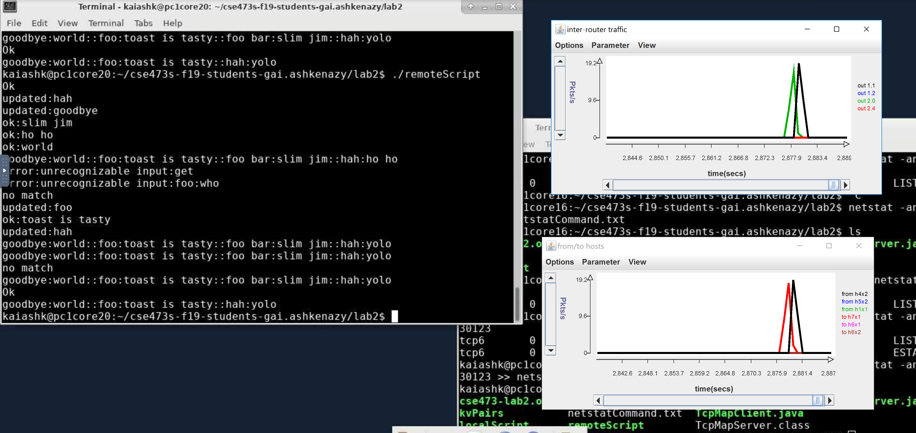

The charts should show a burst of traffic for some of the curves and no traffic for others. Which curves show a burst of traffic? Is this consistent with what you expect? Note that there are two possible routes between the two end hosts. Which of the two routes are used in this case?

*The chart that show a curve of traffic are: in the upper chart (inter-router traffic), we see the two routers that belong to each of the two hosts (NPR1 and NPR2), and in the lower chart we see the two hosts themselves.*

*The charts are indeed consistent with our expectations, because (as we will see shortly) the only two hosts and the only two routers involved in the route between the two hosts are just the ones mentioned above; therefore we see no effect on other hosts or routers, that is, we leave “no trace”.*

*As for the routes: the data travelling between these hosts can take one of two ways; either from h4x2, through NPR1 port 2, to gige0, then to port 4 of NDR2 then eventually to h7x1 (and return respectively), or from h4x1 through port 1 to port 0 of NPR2, straight to h7x1.*

*As we see from the charts, the route chosen by the router is the second one, which is also the shorter one in this case.a.*

***Part F (10 points).*** In this next part, you are to run *remoteScript* once again, but this time, you will be using *Wireshark* to capture packets as seen at both hosts. Using *Wireshark* in *onl* requires a little extra effort, since *Wireshark* itself must run on the target computer within *onl*, while the graphical interface needs to appear on your local computer. Start by opening a new shell window on your Linux desktop (again, use the Virtual Linux Lab to run a remote Linux desktop if you don’t have access to a Linux/Unix machine), and type

ssh -YC blowfish-cbc,arcfour <username>@onl.wustl.edu

This creates an *ssh* connection that forwards “X-windows” commands from *onlusr* back to your Linux desktop, turns compression on, and specifies a more efficient cipher for encryption. X-windows is a generic windowing system developed at MIT in the 1980s. It is still used for a number of *unix*/*linux* applications, including *Wireshark*. Now, type

source /users/onl/.topology   
ssh –YC $h4x2

This will log you into host *h4x2* and forward X-windows commands from *h4x2* back through *onlusr* to your Linux desktop. Next, type

sudo wireshark

After you enter your *onl* password, *Wireshark* will start running on *h4x2*,and the *Wireshark* window will open on your Linux desktop. If you want to do this part of the lab using your own computer, you may have to do some initial configuration. If you have a Mac or a Linux computer, with *Wireshark* installed, you’re probably good to go. Just open a terminal window and type

ssh –X myLogin@onl.wustl.edu

and proceed as described above. Again, if you are not using a Linux/Unix machine, you must use a remote Linux desktop.

Now, configure *Wireshark* to capture packets on the *data0* interface and then re-run *remoteScript* in the original terminal window connected to *h4x2*. Find the packet going from *h4x2* to *h7x1* that includes the “get:goodbye” command. Highlight that packet in the upper sub-window and make sure that the packet contents are visible in the lower sub-window.

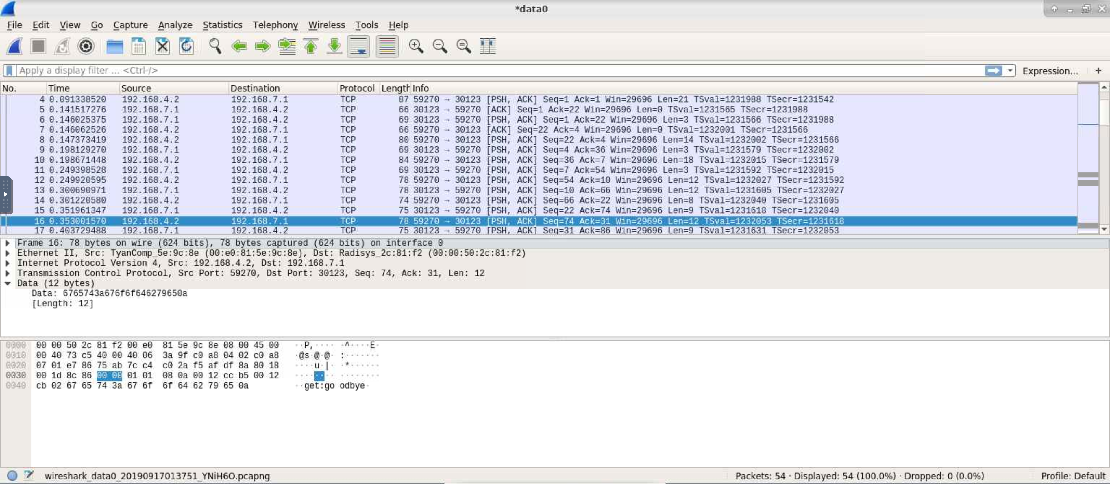

How much time passes between the time this packet is sent and the time the reply arrives? (Note, the reply appears on the next line and the second column of the displays shows the times relative to the start of the capture.)

*The packet was sent at time 0.353 and reply was received at time 0.4037, so the time that passed is approximately 0.05 seconds.*

The observed time is caused primarily by an artificial delay that has been configured in one of the routers, using a special *delay plugin*. Which router contains the delay plugin?

*After analyzing the remote laboratory interface (the topology of the network in the lab), we can see that a delay plugin was installed in NPR.1.*

Find the filter that causes packets to pass through the plugin and turn it off, using the RLI. You can find filters by clicking on an interface and looking at the Filter Table under Configuration. Don’t forget to commit after disabling the filter. Note that if you accidently disable the wrong thing, the whole system could stop working. So don’t be afraid to reopen the original onl file and start over. Now, start a new *Wireshark capture* and re-run *remoteScript*.

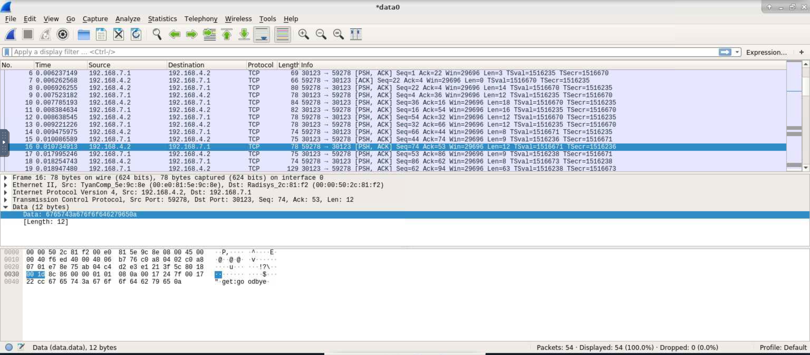

Now, how much time passes between the sending of the packet and the response?

*After turning off the filter, we get the following times. The packet was sent at time 0.01073, and reply was received at time 0.01799. Therefore, the time difference is now 0.00726 seconds, which is smaller than the previous time difference by a factor of 10 approximately.*

***Part G (10 points).*** In this part, you will measure the performance of your application in another way. Run the provided *longScript* on the client. This performs a large number of puts and gets. Make a screen capture of the two monitoring windows showing the packet traffic in the network.

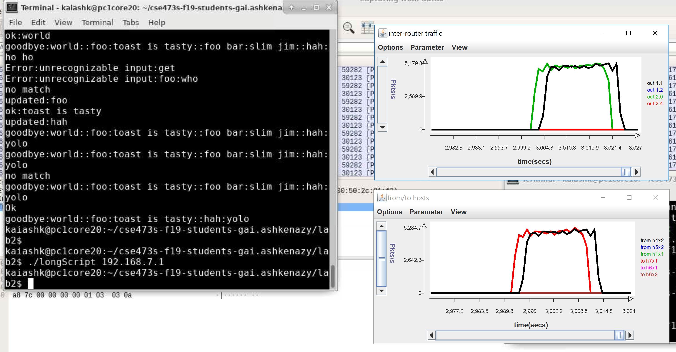

What does the traffic data tell you about the performance of the application?

*We can see from both graphs that the performance of both the server application and the client application is about the same; both receive inputs and output bytes in the same magnitude, which allows high performance of the application.*

*We can also see that there is a slight delay in the beginning of the connection; this might be caused by the filter delay put on the network. But, after the delay passes, the server and client applications “catch up” to speed and perform optimally.*

Repeat the above experiment while running *Wireshark* on *h7x1*. Select a packet going from *h4x2* to *h7x1* from somewhere near the middle of the capture.

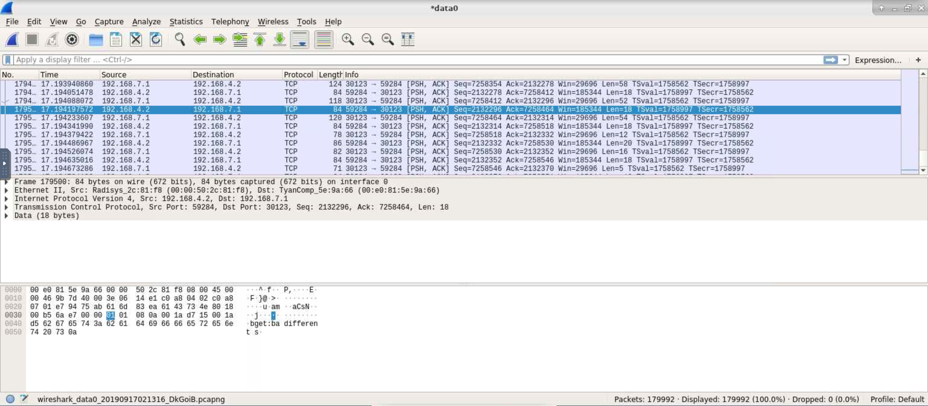

How much time passes between when *h7x1* receives the packet and the time it sends its reply?

*The server (h7x1) receives the packet at time 17.1941, and returns a reply to the client h4x2 at time 17.1942. Therefore, it takes h7x1 0.0001 time to return a reply in total.*

How much time from when *h7x1* receives this packet and the time it receives the next one.

*The server (h7x1) receives the packet at time 17.1941, and receives the next packet at time 17.1943. So it takes 0.0002 seconds between the arrival of these two packet.*

Is this consistent with what you observed based on the packet rate chart?

*In the chart, we can see that the server receives (and sends) approximately 5,000 packets per second. That means that a packet is sent every $\frac{1}{5000}$ second = 0.0002 seconds. Therefore, the time observed in the previous question is indeed consistent with the charts.*